Feedback Guide:

Supporting organisation to submit feedback online

Feedback and consultation is crucial to the ongoing development of our guidance and its applicability and usefulness to market participants. We welcome feedback from all interested stakeholders.

Who can provide feedback?
All types of companies, financial institutions, scientific and academic organisations, civil society and NGO groups, regulators and policymakers, business associations, market service providers and other interest stakeholders are invited to provide feedback.

What publications are open for consultation?
A full list of publications open for consultation and feedback can be found here.
This guidance supplements the final TNFD Recommendations, its disclosure metrics outlined in Annexes 1 and 2, and the guidance on assessing nature-related issues – the LEAP Approach.
The TNFD welcomes feedback on how to improve the guidance, whether the proposed sector metrics are decision-useful and proportionate, and any suggestions for additional metrics.

Providing feedback online

Step 1 | Navigate to the correct publication landing page.  Users can click on ‘All publications’ in the main navigation bar on the website or on ‘Open for consultation’ to navigate to a list of publications open for feedback.  Or the links provided above for specific publication landing pages. | 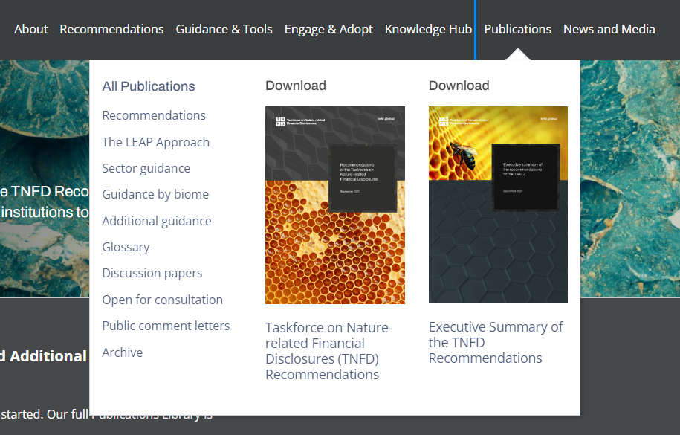
Step 2 | Once on the landing page you can scroll click on any of the Draft sector guidance that is currently open for consultation. | 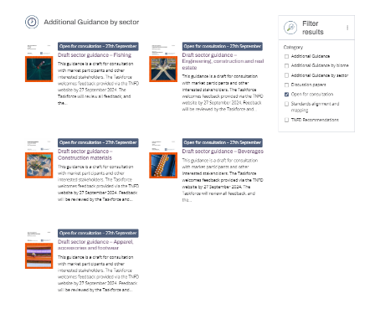
Step 3 | Once you are on a specific publication landing page you will see a green box that says ‘Provide feedback by…’  You must have a TNFD Profile to provide feedback. This takes less than 2 minutes.  Either login or create a profile by clicking the buttons. | 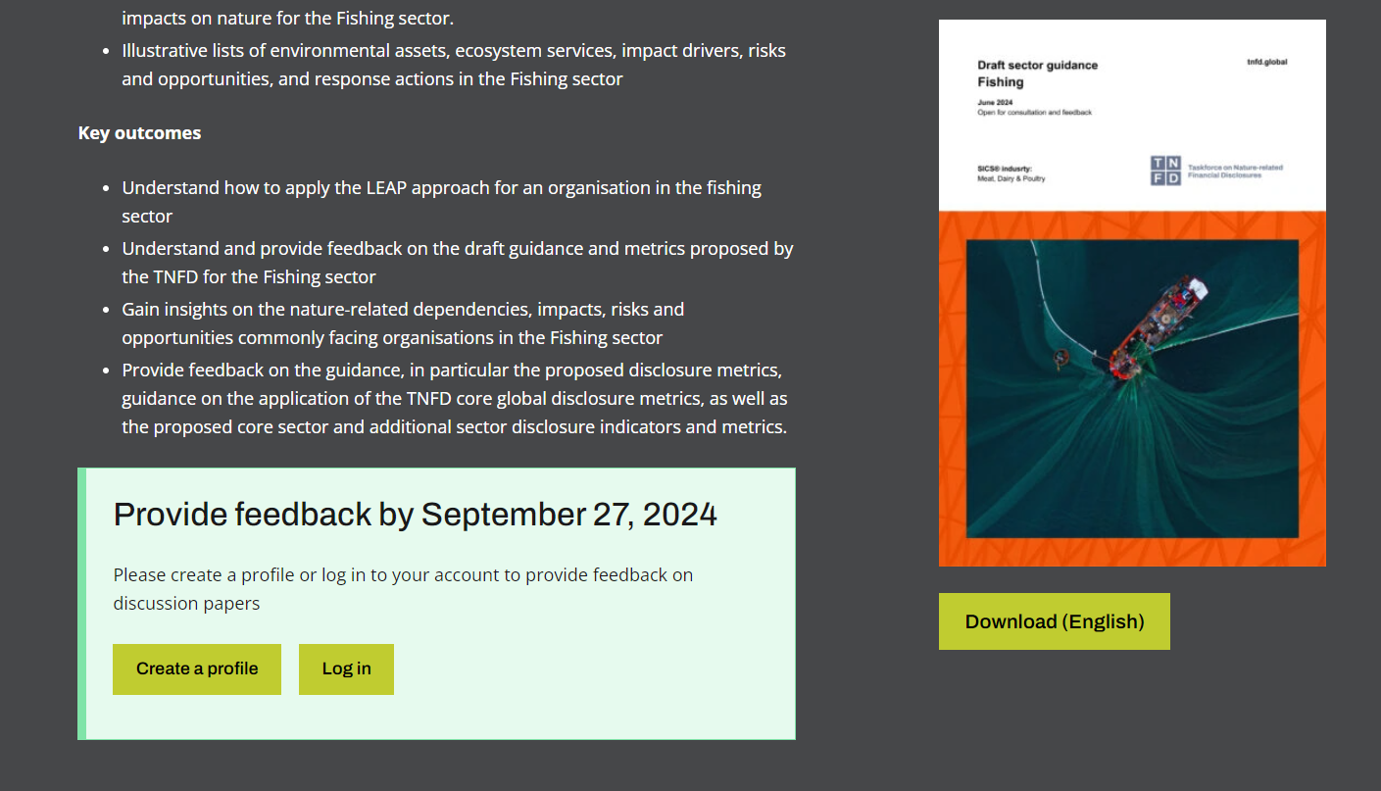
Step 4 | Once logged in, you will be asked if you would like to submit a comment letter. This is optional  Tick ‘yes’ and follow the instructions to upload your comment letter.  Or tick ‘no’ and you will continue to the sector-specific feedback questions. | 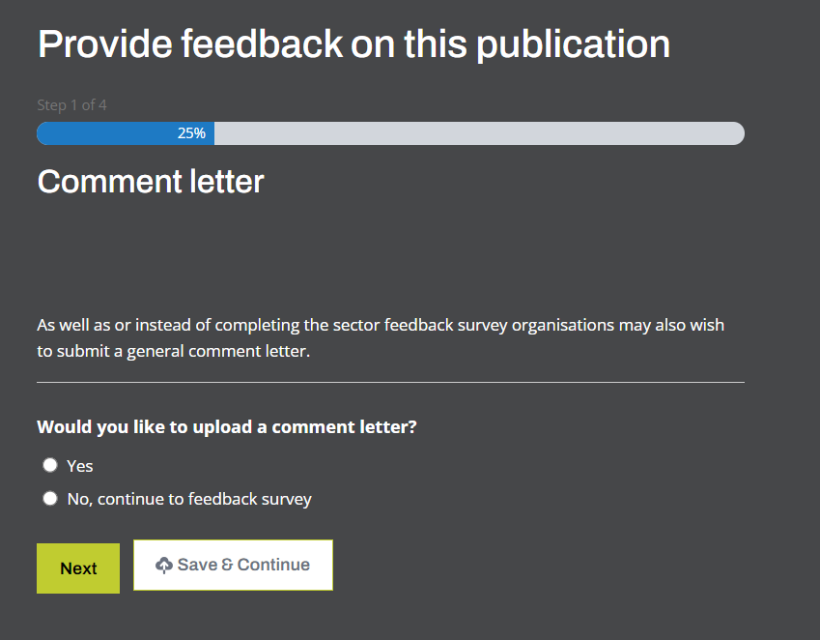
Step 5 | Continue to complete the feedback questions. There are three sections to the survey: General feedback questions, Metrics feedback questions, and Additional sector-specific questions.  When you have completed the questions, click ‘submit’ or you can ‘save’ and return to the survey in the future.  You will receive a confirmation via email. | 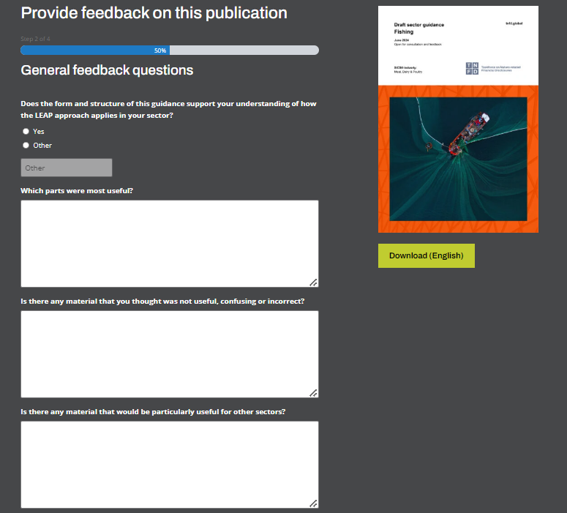

Contact and support

If you have any questions or need further support regarding outreach and communications, please contact the following:

Support team :
- Feedback coordination – Blanche de Biolley – blanche.de-biolley@tnfd.global
- Head of digital communications – Rhys Thomas – Rhys.Thomas@tnfd.global

